Refugees: then and now
Introduction: In July 1938, fewer than 5 percent of Americans surveyed at the time believed that the United States should raise its immigration quotas or encourage political refugees fleeing fascist states in Europe — the vast majority of whom were Jewish — to voyage across the Atlantic. Two-thirds of the respondents agreed with the proposition that "we should try to keep them out."
An interview with Gov. Chris Christie in November 2015: http://www.realclearpolitics.com/video/2015/11/16/chris_christie_no_syrian_refugees_not_even_orphans_under_the_age_of_5.html

QUESTIONS: Why does the USA usually refuse to take in large numbers of refugees? Devise 3 reasons. Do you agree with our policies?
INSTRUCTIONS: Please answer the above questions. Use the evidence in this packet. Work in groups of 3 to determine the answers. Please be respectful of each other’s opinion.

Part I: Evidence from the 1930s. Why were large numbers of Jewish refugees denied entrance into the US?
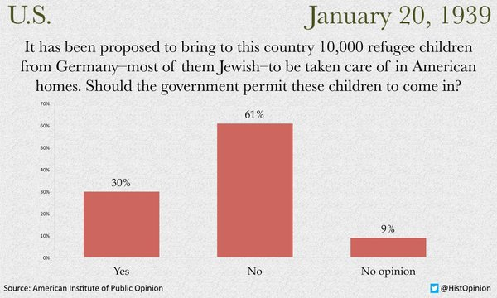
FDR: At a press conference on June 5, 1940, FDR himself warned that “among the refugees there are some spies, as has been found in other countries, and especially Jewish refugees could be coerced to report to German agents under the threat that if they did not do so, ‘we are frightfully sorry, but your old father and mother will be taken out and shot.’ Disguised as refugees, Nazi agents have penetrated all over the world, as spies, fifth columnists, propagandists, or secret commercial agents.”
1939 Antisemitic cartoon:

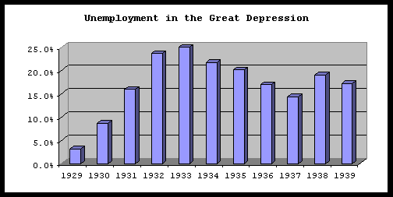
Voices from the 1930s:
John B. Trevor, a congressman, argued against a proposal to settle Jewish refugees in Alaska, claiming they would be potential enemies — and charging that Nazi persecution of the Jews had occurred “in very many cases … because of their beliefs in the Marxian philosophy.”...
Rep. Jacob Thorkelson, a Republican from Montana, warned at the time that Jewish migrants were part of an “invisible government,” an organization he said was tied to the “communistic Jew” and to “Jewish international financiers.”...
Julia Cantacuzene, a Republican activist in New York argued in a front page New York Times article on May 18th, 1938: “I have heard on good authority that an Executive order has given immigration authorities permission to let down the usual bars in favor of the so-called Jewish refugees from Germany. Under these lax regulations, many Communists are coming to this country to join the ranks of those who hate our institutions and want to over throw them.”
MS St. Louis: https://www.youtube.com/watch?v=L_yGf5UBlE8
Part II: Evidence from 2015. Why are large numbers of Syrians denied entrance into the USA and specific states?
Headline from Washington Post, Paris Terror Attack: “A key bit of evidence that emerged in the investigation of the Paris terror attacks, which saw at least 129 people killed on Friday, is a supposed Syrian passport found near the body of one of the slain assailants. It bore the name of a Syrian national who apparently transited through Greece in early October. The document seemed to be an important clue in the untangling of the terror plot. Could one of the terrorists have been a Syrian refugee?”
5 Things to know about Syrian refugees:
https://www.washingtonpost.com/video/world/5-things-to-know-about-syrian-refugees-in-the-us/2015/11/18/37f32df8-8e2a-11e5-934c-a369c80822c2_video.html
Voices from 2015:
Are refugees allowed in Wisconsin?
http://www.nbc15.com/home/headlines/More-governors-announce-their-states-wont-accept-Syrian-Refugees-after-Paris-massacre-350663911.html
President François Hollande declared after the attacks that France will still take in some 30,000 Syrian refugees over the course of the next two years. In spite of the traumas of the past week, Hollande said, "our country has the duty to respect this commitment."
Governor Bobby Jindal. In defending his policy of not allowing Syrian refuges into the state of Louisiana he stated: “America is the most passionate country in the world. We do more for folks around this world, and that’s the nature of the American people. Two things: One, let us drawn a line, a direct line between this refugee crisis and this President’s failed foreign policy. He drew a red line in Syria and did not enforce it. And now we’re seeing millions of refugees, potentially hundreds of thousands going into Europe. The answer is not to put a Band-Aid on this and allow more people to come into America. We should not short circuit, we got a vetting process, we have a normal refugee process. Simply allowing more people into our country doesn’t solve this problem.”
A State Department spokesperson said of the nearly 785,000 refugees admitted through the U.S. Refugee Admissions Program since 9/11, “only about a dozen — a tiny fraction of one percent of admitted refugees — have been arrested or removed from the U.S. due to terrorism concerns that existed prior to their resettlement in the U.S. None of them were Syrian.”
The numbers: Since 2012, the US has accepted 2,174 Syrian refugees – roughly 0.0007% of America’s total population. President Obama has committed to taking 10,000 Syrian refugees in the coming year, five times the number the US has taken in the past four years. Lebanon, whose population was previously an estimated 4.5 million, now has a Syrian refugee population of roughly 1.2 million – meaning that around one in five Lebanese residents is a Syrian refugee. Turkey, which houses more Syrian refugees than any other country, has welcomed 2 million, or 2.67% of its total population of 75 million.
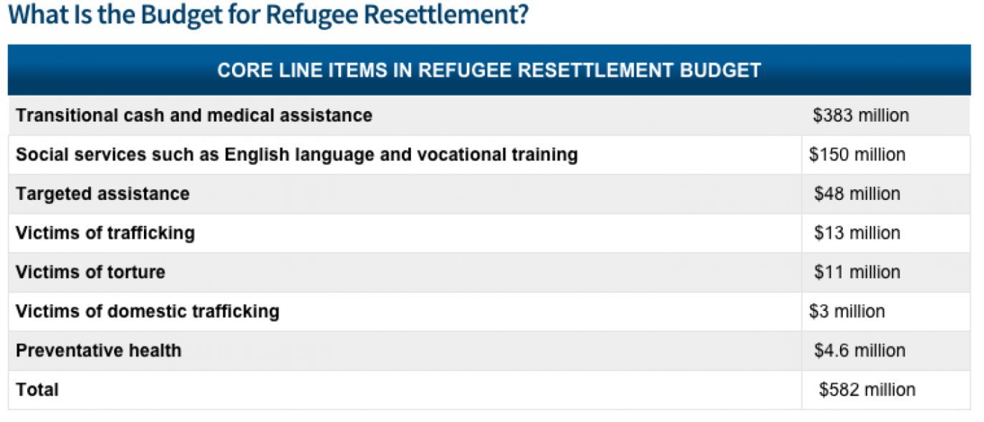
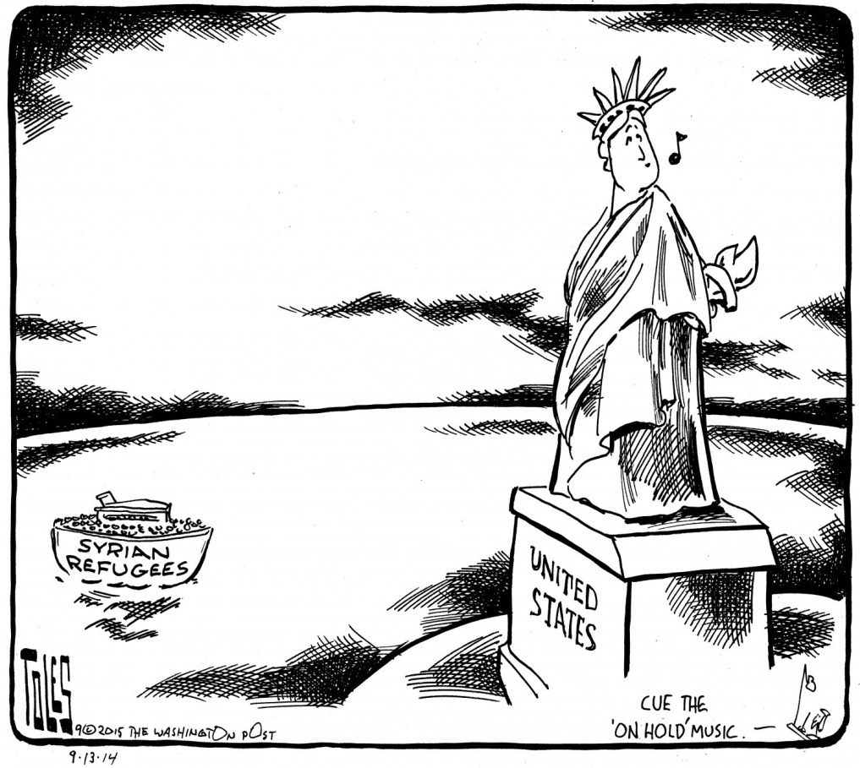

Part III: Follow-up question.
Are there any similarities between the refugee crisis of the 1930s and today?

